Histogram contrast stretching
Original Image:
% xxxxxxxxxxxxxxxxxxxxxxxxxxxxxxxxxxxxxxxxxxxxxxxxxxxxxxxxxxxxxxxx
%% Section 1
% xxxxxxxxxxxxxxxxxxxxxxxxxxxxxxxxxxxxxxxxxxxxxxxxxxxxxxxxxxxxxxxx
% Print on Matlab
figure(Name="Section 1");
myimage = imread('pout.tif');
imshow(myimage)
% Convert Image into Double for processing on matlab
id_double = (myimage/255);
% Assign image height and width to r and c variables
[r,c] = size(id_double);

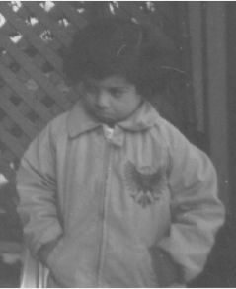
Histogram Plot of the image
% xxxxxxxxxxxxxxxxxxxxxxxxxxxxxxxxxxxxxxxxxxxxxxxxxxxxxxxxxxxxxxxx
%% Section 2 :
% xxxxxxxxxxxxxxxxxxxxxxxxxxxxxxxxxxxxxxxxxxxxxxxxxxxxxxxxxxxxxxxx
% Plot the histogram of the image
figure(Name="Section 2");
imhist(myimage);

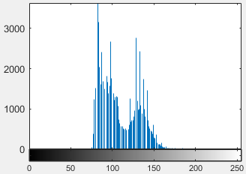
Majority of the pixels are distributed from 75 to 150 of intensity value.
Contrast Stretching : Spreading out gray level distribution.
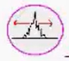
Contrast stretching is a fundamental image enhancement technique that broadens the range of intensity levels within an image so that it fully utilises the available display or recording range. By redistributing pixel intensities, this method improves the visual contrast of the image, making details in dark and bright regions more distinguishable.
A common approach involves using the image histogram to determine how the pixel values are spread. The transformation, also referred to as normalisation, stretches the input intensity range so that it occupies a wider or full dynamic range in the output image.
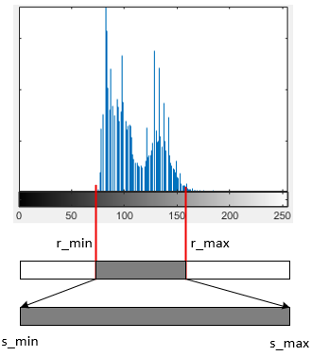

Mathematically, the transformation is defined as:
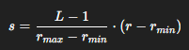
where:
- $r$ is the intensity (pixel value) of the original image, typically in the range [0, 255];
- $r_{max}$ and $r_{min}$ represent the maximum and minimum intensity levels (brightest and darkest pixels) of the input image;
- $s$ is the transformed (output) pixel value after contrast stretching;
- $L-1$ denotes the highest gray value in the image (usually $L=256$)

% xxxxxxxxxxxxxxxxxxxxxxxxxxxxxxxxxxxxxxxxxxxxxxxxxxxxxxxxxxxxxxxx
%% Section 3 : Histogram stretching
% xxxxxxxxxxxxxxxxxxxxxxxxxxxxxxxxxxxxxxxxxxxxxxxxxxxxxxxxxxxxxxxx
% Majority of the pixels are distributed from 75 to 150 of intensity value.
% Input image -> 75/255 = 0.3 , 150/255 = 0.6
% Stretch value between 0 and 255/255=1
imh = imadjust(myimage,[0.3,0.6],[0.0,1.0]);
figure(Name="Section 3");
subplot(1,2,1) ; imshow(imh);
subplot(1,2,2) ; imhist(imh);

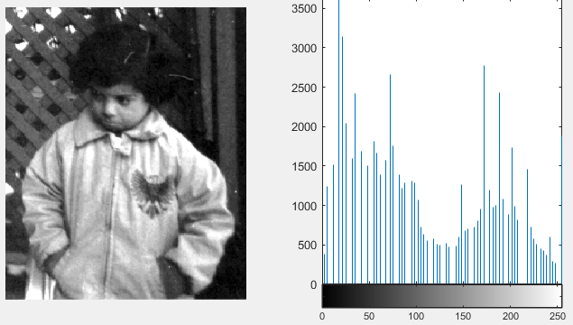
During the stretching, the shape of the histogram doesn’t change. So shape is retained but stretched.

